Assignment 1
Question:
Find the highest, lowest, sum, and average salary of all employees. Label the columns Maximum, Minimum, Sum, and Average, respectively.
Query:
SELECT MAX(SAL) AS Maximum,
MIN(SAL) AS Minimum,
SUM(SAL) AS Sum,
ROUND(AVG(SAL)) AS Average
FROM EMP_WIPRO;
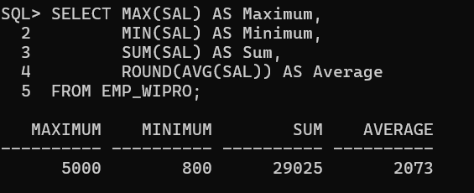
Assignment 2
Question:
Maximum, Minimum, Sum, and Average, respectively. Round your results to the nearest whole number.
Query:
SELECT ROUND(MAX(SAL)) AS Maximum,
ROUND(MIN(SAL)) AS Minimum,
ROUND(SUM(SAL)) AS Sum,
ROUND(AVG(SAL)) AS Average
FROM EMP_WIPRO;
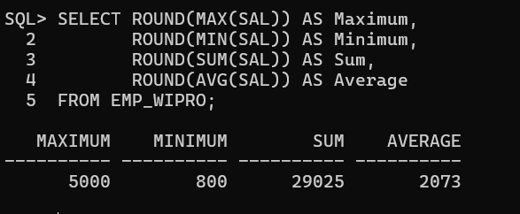
Assignment 3
Question:
Modify the above query to display the minimum, maximum, sum, and average salary for each job type.
Query:
SELECT JOB,
MIN(SAL) AS Minimum,
MAX(SAL) AS Maximum,
SUM(SAL) AS Sum,
ROUND(AVG(SAL)) AS Average
FROM EMP_WIPRO
GROUP BY JOB;
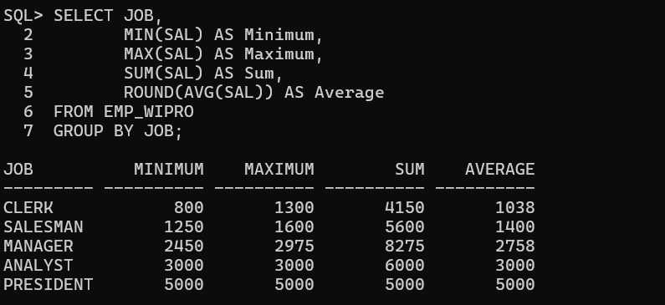
Assignment 4
Question:
Write a query to display the number of people with the same Job.
Query:
SELECT JOB,
COUNT(*) AS Number_of_Employees
FROM EMP_WIPRO
GROUP BY JOB;

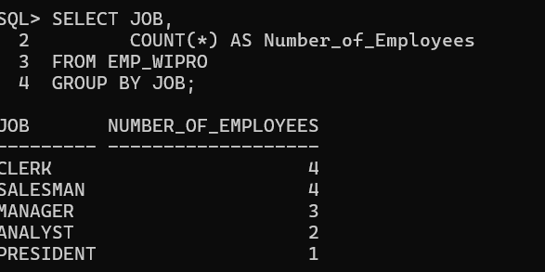

Assignment 5
Question:
Determine the number of managers without listing them. Label the column Number of Managers.
Query:
SELECT COUNT(DISTINCT MGR) AS "Number of Managers"
FROM EMP_WIPRO;
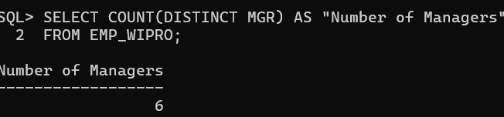
Assignment 6
Question:
Find the difference between the highest and lowest salaries. Label the column DIFFERENCE.
Query:
SELECT MAX(SAL) - MIN(SAL) AS DIFFERENCE
FROM EMP_WIPRO;
Output:
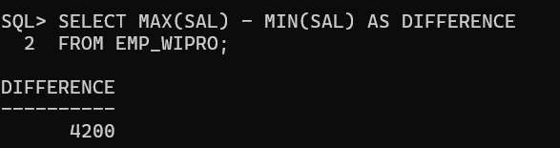
Assignment 7
Question:
Create a report to display the manager number and the salary of the lowest-paid employee for that manager. Exclude anyone whose manager is not known. Exclude any groups where the minimum salary is $2000 or less. Sort the output in descending order of salary.
Query:
SELECT MGR,
MIN(SAL) AS Lowest_Salary
FROM EMP_WIPRO
WHERE MGR IS NOT NULL
GROUP BY MGR
HAVING MIN(SAL) > 2000
ORDER BY Lowest_Salary DESC;

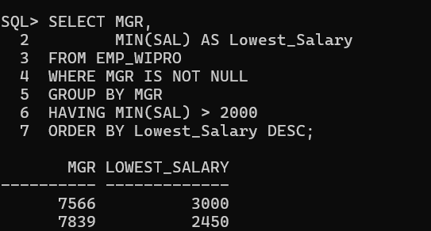

Assignment 8
Question:
Create a query to display the total number of employees and, of that total, the number of employees hired in 1980, 1981, and 1982. Create appropriate column headings.
Query:
SELECT COUNT(*) AS "Total Employees",
SUM(CASE WHEN EXTRACT(YEAR FROM HIREDATE)=1980 THEN 1 ELSE 0 END) AS "Hired in 1980",
SUM(CASE WHEN EXTRACT(YEAR FROM HIREDATE)=1981 THEN 1 ELSE 0 END) AS "Hired in 1981",
SUM(CASE WHEN EXTRACT(YEAR FROM HIREDATE)=1982 THEN 1 ELSE 0 END) AS "Hired in 1982"
FROM EMP_WIPRO;
